MODULE: 1

SE – Overview of IT Industry

1. What is software? What is software engineering?

2. Explain types of software

3. What is SDLC? Explain each phase of SDLC

4. What is DFD? Create a DFD diagram on Flipkart

5. What is Flow chart? Create a flowchart to make addition of two numbers

6. What is Use case Diagram? Create a use-case on bill payment on paytm.

1. What is software? What is software engineering?

Software is a set of instructions, data or programs used to operate computers and execute specific tasks. It is the opposite of hardware, which describes the physical aspects of a computer. Software is a generic term used to refer to applications, [scripts](https://www.techtarget.com/whatis/definition/script) and programs that run on a device. It can be thought of as the variable part of a computer, while hardware is the invariable part.

The two main categories of software are [application](https://www.techtarget.com/searchsoftwarequality/definition/application) software and [system software](https://www.techtarget.com/whatis/definition/system-software). An application is software that fulfills a specific need or performs tasks. System software is designed to run a computer's hardware and provides a platform for applications to run on top of.

Other types of software include programming software, which provides the programming tools software developers need; [middleware](https://www.techtarget.com/searchapparchitecture/definition/middleware), which sits between system software and applications; and driver software, which operates computer devices and peripherals.

What is software engineering

**Software engineering** is the branch of computer science that deals with the **design, development, testing, and maintenance of software applications**. Software engineers apply engineering principles and knowledge of programming languages to build software solutions for end users.

Software engineers design and develop computer games, business applications, operating systems, network control systems, and middleware—to name just a few of the many career paths available.

2. Explain types of software

* Application software. The most common type of software, application software is a computer software package that performs a specific function for a user, or in some cases, for another application. An application can be self-contained, or it can be a group of programs that run the application for the user. Examples of [modern applications](https://www.techtarget.com/searchcio/feature/The-rise-of-modern-applications-Why-you-need-them) include office suites, graphics software, databases and database management programs, web browsers, word processors, software development tools, image editors and communication platforms.
* System software. These software programs are designed to run a computer's application programs and hardware. System software coordinates the activities and functions of the hardware and software. In addition, it controls the operations of the computer hardware and provides an environment or platform for all the other types of software to work in. The OS is the best example of system software; it manages all the other computer programs. Other examples of system software include the [firmware](https://www.techtarget.com/whatis/definition/firmware), computer language translators and system [utilities](https://www.techtarget.com/whatis/definition/utility).
* Driver software. Also known as device drivers, this software is often considered a type of system software. Device drivers control the devices and peripherals connected to a computer, enabling them to perform their specific tasks. Every device that is connected to a computer needs at least one device driver to function. Examples include software that comes with any nonstandard hardware, including special game controllers, as well as the software that enables standard hardware, such as USB storage devices, keyboards, headphones and printers.
* Middleware. The term *middleware* describes software that mediates between application and system software or between two different kinds of application software. For example, middleware enables Microsoft Windows to talk to Excel and Word. It is also used to send a remote work request from an application in a computer that has one kind of OS, to an application in a computer with a different OS. It also enables newer applications to work with legacy ones.
* Programming software. Computer programmers use programming software to write code. Programming software and programming tools enable developers to develop, write, test and [debug](https://www.techtarget.com/searchsoftwarequality/definition/debugging) other software programs. Examples of programming software include assemblers, compilers, debuggers and interpreters.

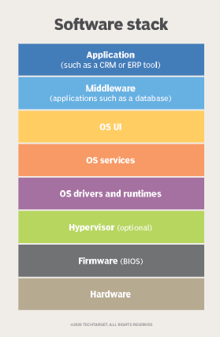

1. What is SDLC? Explain each phase of SDLC

The Software Development Life Cycle (SDLC) is a structured process that enables the production of high-quality, low-cost software, in the shortest possible production time. The goal of the SDLC is to produce superior software that meets and exceeds all customer expectations and demands.

SDLC Cycle

SDLC Cycle represents the process of developing software. SDLC framework includes the following steps:

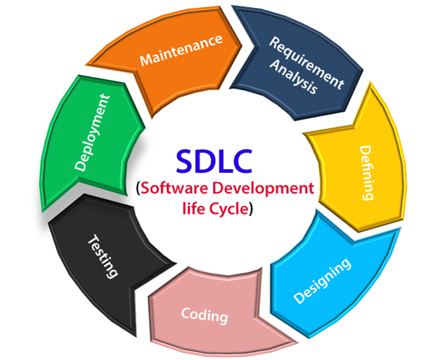

The stages of SDLC are as follows:

Stage1: Planning and requirement analysis

Requirement Analysis is the most important and necessary stage in SDLC.

The senior members of the team perform it with inputs from all the stakeholders and domain experts or SMEs in the industry.

Planning for the quality assurance requirements and identifications of the risks associated with the projects is also done at this stage.

Business analyst and Project organizer set up a meeting with the client to gather all the data like what the customer wants to build, who will be the end user, what is the objective of the product. Before creating a product, a core understanding or knowledge of the product is very necessary.

Stage2: Defining Requirements

Once the requirement analysis is done, the next stage is to certainly represent and document the software requirements and get them accepted from the project stakeholders.

This is accomplished through "SRS"- Software Requirement Specification document which contains all the product requirements to be constructed and developed during the project life cycle.

Stage3: Designing the Software

The next phase is about to bring down all the knowledge of requirements, analysis, and design of the software project. This phase is the product of the last two, like inputs from the customer and requirement gathering.

Stage4: Developing the project

In this phase of SDLC, the actual development begins, and the programming is built. The implementation of design begins concerning writing code. Developers have to follow the coding guidelines described by their management and programming tools like compilers, interpreters, debuggers, etc. are used to develop and implement the code.

Stage5: Testing

After the code is generated, it is tested against the requirements to make sure that the products are solving the needs addressed and gathered during the requirements stage.

During this stage, unit testing, integration testing, system testing, acceptance testing are done.

Stage6: Deployment

Once the software is certified, and no bugs or errors are stated, then it is deployed.

Then based on the assessment, the software may be released as it is or with suggested enhancement in the object segment.

After the software is deployed, then its maintenance begins.

Stage7: Maintenance

Once when the client starts using the developed systems, then the real issues come up and requirements to be solved from time to time.

This procedure where the care is taken

4. What is DFD? Create a DFD diagram on Flipkart

**DFD** is the abbreviation for **Data Flow Diagram**. The flow of data of a system or a process is represented by DFD. It also gives insight into the inputs and outputs of each entity and the process itself. DFD does not have control flow and no loops or decision rules are present. Specific operations depending on the type of data can be explained by a flowchart. It is a graphical tool, useful for communicating with users ,managers and other personnel. it is useful for analyzing existing as well as proposed system.

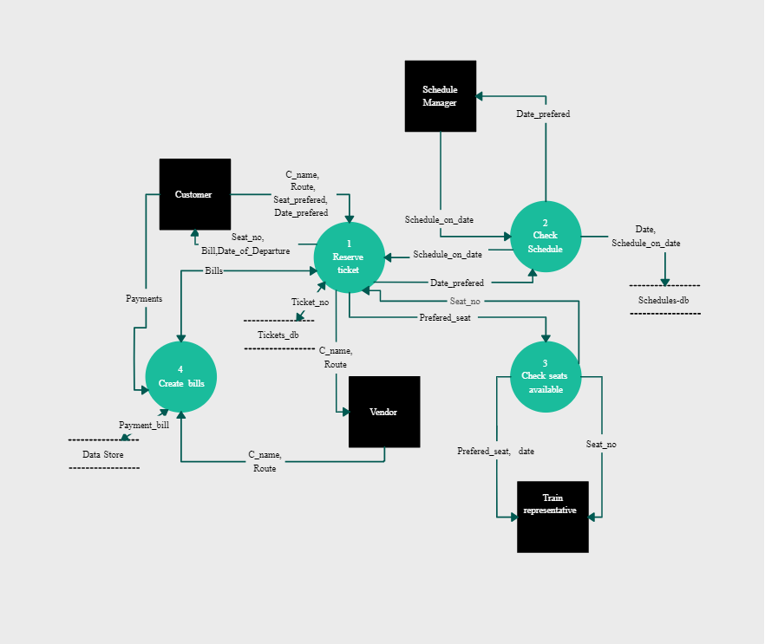

5. What is Flow chart? Create a flowchart to make addition of two numbers

A flowchart is a diagram that depicts a process, system or computer algorithm. They are widely used in multiple fields to document, study, plan, improve and communicate often complex processes in clear, easy-to-understand diagrams. Flowcharts, sometimes spelled as flow charts, use rectangles, ovals, diamonds and potentially numerous other shapes to define the type of step, along with connecting arrows to define flow and sequence.

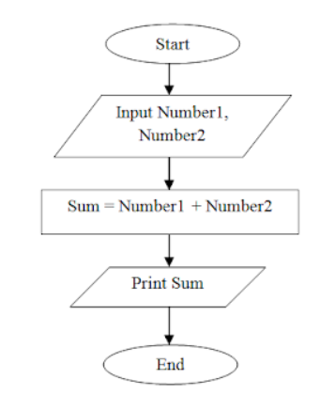

6. What is Use case Diagram? Create a use-case on bill payment on paytm.

A use case diagram is used to represent the dynamic behavior of a system. It encapsulates the system's functionality by incorporating use cases, actors, and their relationships. It models the tasks, services, and functions required by a system/subsystem of an application. It depicts the high-level functionality of a system and also tells how the user handles a system.

## Purpose of Use Case Diagrams

The main purpose of a use case diagram is to portray the dynamic aspect of a system. It accumulates the system's requirement, which includes both internal as well as external influences. It invokes persons, use cases, and several things that invoke the actors and elements accountable for the implementation of use case diagrams. It represents how an entity from the external environment can interact with a part of the system.

